File handling past paper Questions



2018

2019

2022- session 1

Session 2

2023 – session 1

Session 2

Extra model paper question



2018

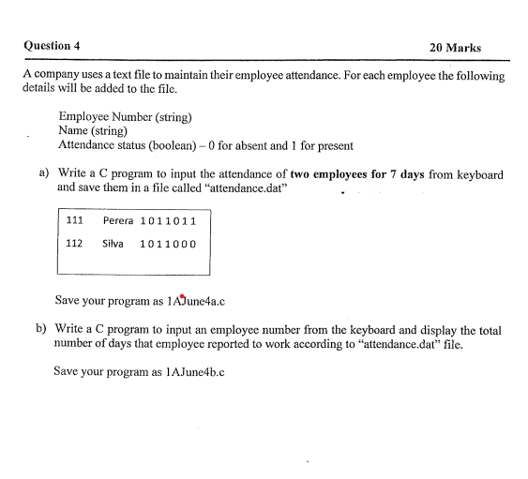

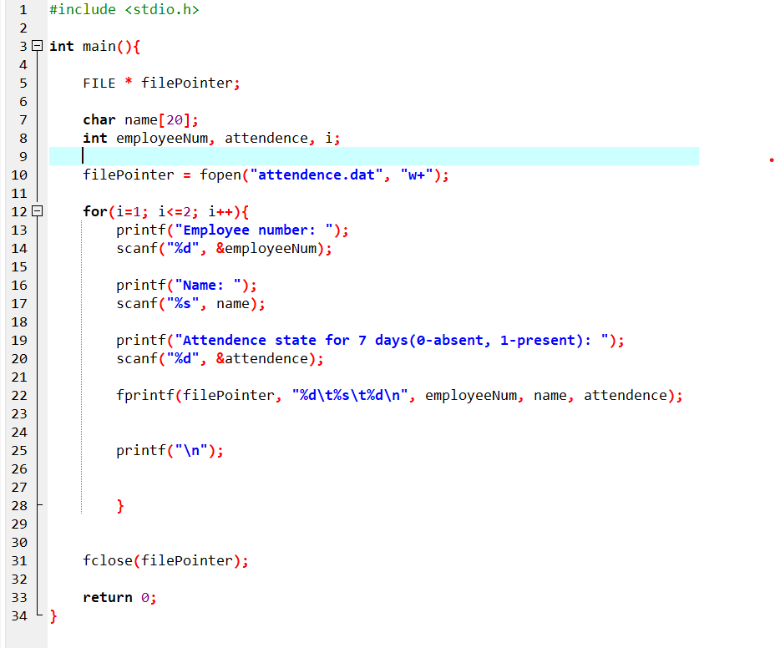

2019

2022 – session1

2022 – session2

2023 – session1

2023 - session2

Extra question model paper

